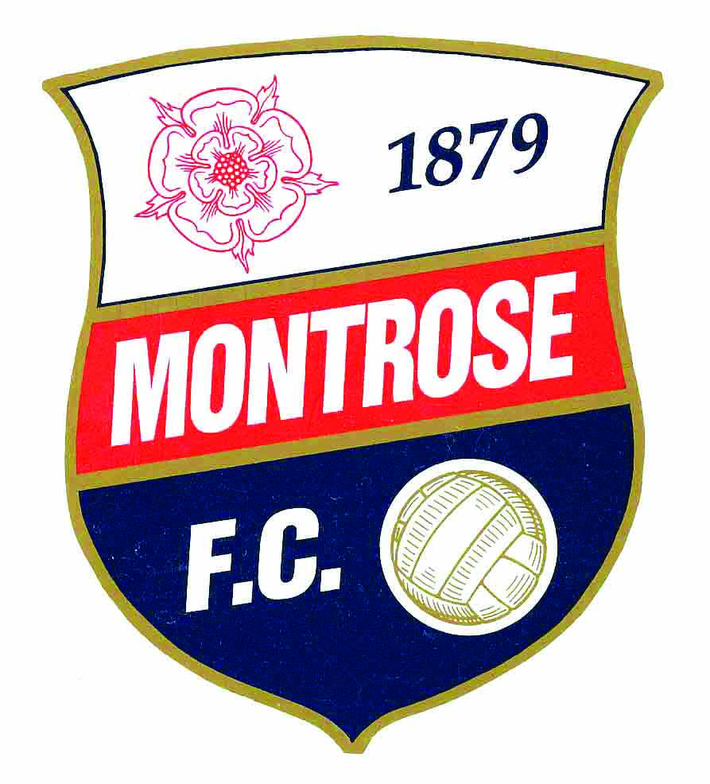

MONTROSE FOOTBALL CLUB
GOLF DAY
(in aid of YOUTH DEVELOPMENT)
ON
FRIDAY 8th SEPTEMBER 2017
MONTROSE GOLF LINKS
CHAMPIONSHIP COURSE
(HOST CLUB – ROYAL MONTROSE GC)

SHOTGUN START
COMMENCING 1.00PM

ENTRY £200 PER TEAM OF 4, INCLUDING BACON BUTTIE, COFFEE AND 2 COURSE MEAL.
SPONSORSHIP OF EACH HOLE / NEAREST THE PIN AND LONGEST DRIVE ONLY £50
ENTRY FORMS & CHEQUE PAYABLE TO MONTROSE FC Development Fund CAN BE SENT TO:
Montrose Football Club / John Crawford, 72 New Wynd, / Alistair Hogg, Henry Hogg Booksellers, High St or Jason Boyd, Professional, Montrose Golf Links.

